|  |  |
| --- | --- |
|  | Sanjivani College of Engineering, Kopargaon  **(An Autonomous Institute)**  Department of Information Technology Engineering |

CERTIFICATE

This is to certify that

### Shekhar Vishnu Bhide

**B. Tech A UIT20M1007**

Has successfully completed his Internship on

## “CIP Course Program By GeeksForGeeks”

Towards the partial fulfilment of B. Tech. (Information Technology Engineering) during the academic year 2023-2024

Prof. S. Muthuraj Dr. M. A. Jawale

**Mentor/Coordinator HOD**

## Certificate of Originality

This is to certify that the Internship report entitled “**CIP Course Program By GeeksForGeeks**” submitted to Savitribai Phule Pune University, Pune in partial fulfilment of the requirements for the award of the degree for B. Tech (Information Technology) is an authentic and original work / course completed by **Mr. Shekhar Vishnu Bhide** with Seat no **UIT20M1007** under my guidance at Sanjivani College of Engineering Kopargaon

The matter embodied in the report is the genuine work/course completed by the student and not copied or stolen from anywhere else.

Date:

Name: Shekhar Vishnu Bhide Name of Mentor: Prof. S. Muthuraj

Mobile no.: 9921980249 Mobile no.: 9940888872

Email id: [shekharbhide036@gmail.com](mailto:shekharbhide036@gmail.com) Email id:

The internship work presentation of Mr. Shekhar Vishnu Bhide is conducted on

#### Internal Examiner External Examiner

1. Certificate
2. Certificate of Originality
3. Title of the internship
4. Duration
5. Introduction
6. Objectives
7. Significance & the Importance
8. Internship Detail
9. Different Technologies Learned during internship
10. Applications
11. Conclusion
12. References

**Annexure A** Evaluation record **Annexure** B Certificates

**Title of the Internship**: CIP Course Program By GeeksForGeeks

**Duration:** 26th February 2024 to 30th June 2024

## Brief Introduction:

This internship provides an immersive learning journey centered around mastering C++ programming and Data Structures and Algorithms (DSA). Through a blend of live mentor-led classes and hands- on problem-solving sessions, participants delve into the intricacies of essential data structures such as arrays, linked lists, stacks, and queues, mastering their implementation in C++. With a focus on fundamental algorithms like sorting and searching, interns tackle complex real-world challenges, honing their problem-solving prowess. Additionally, engagement in coding competitions and practice platforms like LeetCode and HackerRank fosters the development of speed and accuracy, essential skills for navigating the dynamic landscape of software development.

Off the job, interns immerse themselves in a diverse range of learning activities designed to deepen their understanding and mastery of DSA concepts. Through weekly contests challenging them to solve problems under timed conditions, interns assess their comprehension and refine their problem- solving speed. Meanwhile, the practice section offers a flexible environment for self-paced learning, with video lectures, quizzes, and problem-solving opportunities available without time limitations. This dual approach, blending structured guidance with self-directed exploration, ensures interns are equipped with a robust skill set and the confidence to tackle complex coding challenges beyond the confines of the internship.

#### Develop a Strong Foundation in C++ and DSA:

* + Gain a comprehensive understanding of essential data structures (arrays, linked lists, stacks, queues etc.) and their implementation in C++.
  + Learn and apply fundamental algorithms (sorting, searching, etc.) to solve complex problems efficiently.

#### Enhance Problem-Solving Skills:

* + Engage in hands-on coding exercises and projects that challenge you to implement data structures and algorithms to solve real-world problems.
  + Participate in coding competitions and practice platforms (e.g., LeetCode, HackerRank) to improve speed and accuracy in problem-solving.

#### Understand the Importance of Algorithmic Efficiency:

* + Analyze the time and space complexity of algorithms to understand their efficiency and scalability.
  + Learn to optimize code by selecting appropriate data structures and algorithms based on problem requirements

1. Innovation Catalyst: Internships serve as a breeding ground for innovation, allowing interns to bring fresh perspectives and ideas to the table, which can lead to breakthroughs in products or processes.
2. Mastery of C++ and Data Structures and Algorithms (DSA) forms the foundation for success in software development roles.
3. Proficiency in C++ opens doors to diverse career opportunities across various domains.
4. Understanding DSA is essential for efficiently solving complex problems and optimizing code performance.
5. Hands-on problem-solving and participation in coding competitions foster critical thinking and analytical skills.
6. Competitive programming platforms enhance participants' ability to devise efficient solutions using the best algorithms and data structures.
7. The internship's balanced approach combines structured guidance with self-paced learning, cultivating self-reliance and adaptability.
8. Participants develop a mindset of continuous learning and growth, essential for navigating the dynamic tech landscape.
9. The skills acquired during the internship are highly sought-after by employers in the tech industry.
10. Graduates of the internship are well-equipped to tackle real-world challenges and excel in technical interviews.
11. Overall, the internship plays a crucial role in preparing individuals for successful careers in software development.

# Internship Details

* + Company Name: GeeksForGeeks
  + Location: Virtual
  + Internship Period: 26th February to 30th June 2024
  + Selection Process: Online Enrollment
  + Course Internship Title: CIP(Complete Interview Preparation) Course Program
  + Domain: DSA with C++
  + Mail: [shekharbhide036@gmail.com](mailto:shekharbhide036@gmail.com)
  + Mentor : Gourav Kumar Shaw

### Technology Used:

* + 1. C
    2. CPP
    3. Python
    4. SQL

### Skills Developed:

#### Technical Skills:

* + 1. I developed proficiency in C++ programming language, including memory management and optimization techniques.
    2. I master fundamental data structures such as arrays, linked lists, stacks, and queues.
    3. Additionally, I gained understanding and implementation skills in advanced data structures like trees, graphs, and hash tables.
    4. I also acquired knowledge and application expertise in essential algorithms for sorting, searching, and dynamic programming.
    5. Finally, I enhanced my problem-solving abilities and algorithmic efficiency through hands-on sessions and coding competitions.

#### Soft Skills:

1. Communication skills are developed through engagement in live classes and collaboration with peers.
2. Additionally, there is cultivation of a growth mindset, fostering adaptability and embracing opportunities for improvement.
3. Improvement of critical thinking and creativity is achieved through problem-solving activities and coding competitions.
4. Moreover, enhanced adaptability enables interns to approach challenges systematically and think innovatively.
5. Finally, the development of perseverance and resilience is nurtured in navigating through setbacks and challenges.
6. **Software Development Roles**: Graduates of this internship are well-equipped for roles in software development across various industries. They can work as software engineers, developers, or programmers, leveraging their expertise in C++ programming and data structures to build robust and efficient software solutions.
7. **Tech Companies**: The skills acquired during the internship are highly sought after by tech companies, including startups, mid-sized firms, and large corporations. Participants can pursue opportunities in companies like Google, Facebook, Microsoft, and Amazon, contributing to the development of cutting-edge technologies.
8. **IT Consulting Firms**: Consulting firms specializing in IT services often seek professionals with strong technical skills and problem-solving abilities. Interns can explore roles in IT consulting, where they assist clients in implementing software solutions, optimizing performance, and overcoming technical challenges.
9. **Fintech and E-commerce**: Industries such as fintech and e-commerce heavily rely on technology for their operations. Graduates of this internship can find roles in developing financial software, designing e-commerce platforms, and implementing algorithms for data analysis and customer engagement.
10. **Gaming Industry**: With expertise in C++ programming and data structures, participants can pursue careers in the gaming industry, working on game development projects. They can contribute to designing game mechanics, optimizing performance, and implementing complex algorithms for game logic and artificial intelligence.
11. **Machine Learning and Data Science**: Proficiency in programming and algorithms is essential for roles in machine learning and data science. Interns can apply their skills to develop algorithms for data analysis, implement machine learning models, and optimize performance for large-scale data processing tasks.
12. **Cybersecurity**: Understanding data structures and algorithms is crucial for cybersecurity professionals in analyzing and securing systems against cyber threats. Graduates can explore roles in cybersecurity, working on threat detection, encryption techniques, and vulnerability assessments.

In conclusion, the CIP course internship offers a comprehensive learning journey that prepares participants for the dynamic landscape of software development. Through a combination of technical instruction, hands-on problem-solving, and engagement in coding competitions, interns develop proficiency in C++ programming and master essential data structures and algorithms.

Alongside technical skills, the internship fosters the cultivation of soft skills such as communication, critical thinking, and adaptability, essential for navigating complex projects and collaborating effectively in team environments. Armed with this diverse skill set, graduates are poised to pursue diverse career opportunities across industries, ranging from tech giants to consulting firms, fintech, e-commerce, gaming, cybersecurity, and academic research.

Ultimately, the internship serves as a pivotal platform for individuals to embark on successful and fulfilling careers in the ever-evolving field of software development and other fields

* + <https://www.geeksforgeeks.org/>
  + <https://media.geeksforgeeks.org/courses/certificates/861568bc148c1065c8025c6e3691be95.pdf>

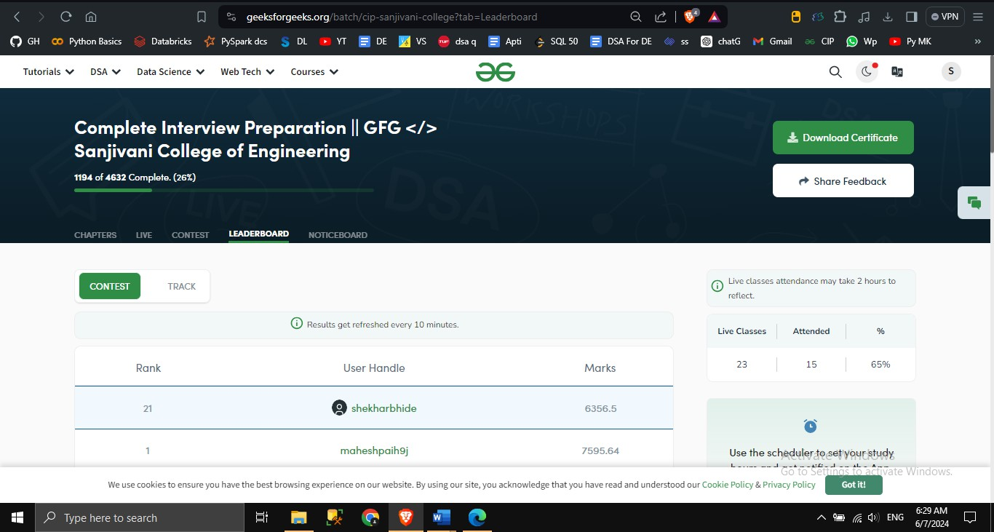

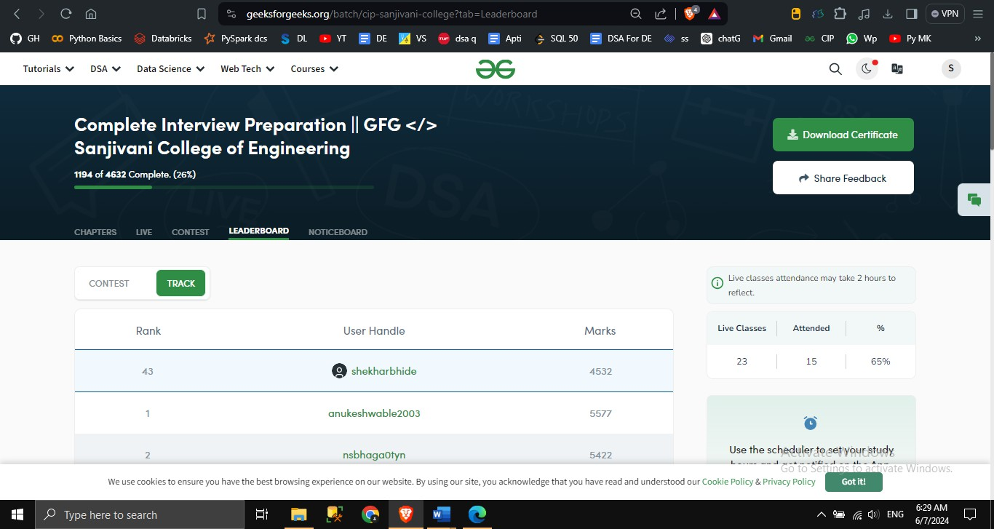

**Annexure B**

